

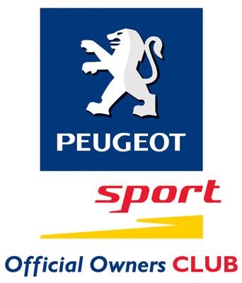

PEUGEOT ANNIVERSARY TOUR 2004

THE PEUGEOT ANNIVERSARY RUN!

Join the largest gathering of 205’s as The Peugeot Sport Official Owners Club head out for a long weekend continental tour to the beautiful Alsace-Lorraine region of eastern France celebrating the 20th Anniversary of the Peugeot 205 GTi. Based in and around the city of Mulhouse the tour will include hotels, ferry crossings, driving events, gala dinner and even a track day session. And, don’t worry about getting lost – the entire route has been pre-driven and each car will get a full marked up ‘rally style road book’ which will combine the motorways with some great back-road driving to make the most of your journey.

Perhaps best of all, the event is excellent value (from just £235) and of course you will be doing the tour along with a group of like minded enthusiasts – it’s going to be a memorable event.

The Peugeot Sport Official Owners Club have teamed up with driving event organisers – Wildside (www.adren-a-line.com) the company behind The Peugeot Sport Club Welsh Weekend events, to stage the Anniversary Run. With over 10 years experience of arranging European driving tours and events you can be confident that this will be a great weekend with all the hassle of getting a hotel, planning your route, booking up visits and tours etc., all taken care of – you can get on with enjoying yourselves!.

The Anniversary Run will include:

☑ Return ferry crossings from Dover to Calais for car and passengers
☑ Escorted drive down route with full road books and route maps
☑ 3 nights quality accommodation in Mulhouse
☑ Welcome beer reception on arrival in Mulhouse
☑ Breakfast each day
☑ Four course gala dinner on Saturday night
☑ Car parking
☑ Special Tour Information Pack with restaurants, bars, maps etc., of the Mulhouse area
☑ Entry included to the fabulous world- famous Schlumpf Collection Automobile Museum
☑ Treasure Hunt Rally with prizes
☑ Anniversary Concours with prizes
☑ Visit to the Sochaux Peugeot factory – the birthplace of the 205
☑ Wine tasting sessions
☑ Race track session at private circuit
☑ Optional Sunday country side drive out with pre-planned routes
☑ The Run is open to all Peugeots – no matter what model you drive
☑ Fully escorted throughout
☑ £5,000,000 Tour Operators liability insurance

Day 1 – The group assemble at Dover docks to check in for the short ferry crossing over to Calais, France. Aimed at the driving enthusiast, this tour is operated as a Grand Touring event. Full road books and route maps are supplied with regular regrouping points as we head east through the beautiful Champagne countryside and into the Alsace-Lorraine region. The route will combine motorways with hand-picked ‘B’ roads selected for their driving potential and there will also be an optional treasure hunt which you can enter for free to keep you entertained on the way down. There will of course be prizes for the winners….

Arrival at Mulhouse will be in the late afternoon/early evening and join us for a welcoming beer and a chat about the weekend ahead. Friday night has been kept free for you to relax. A selection of restaurants and bars will be included in the Tour Information Pack.

Over the course of the weekend you will be able to take part in a variety of events including the Schlumpf visit, the Sochaux factory visit, wine tasting sessions, the Alsace Countryside Drive Out etc.,

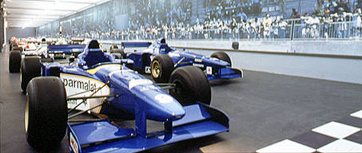

Dinner will be taken alongside the motor racing collection……

Full information and timings of the activities will be in the information pack which will be sent to you prior to the event.

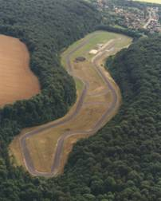
On Saturday evening we have booked the fascinating motor racing hall at the Schlumpf museum for a gala dinner for the whole group where you will be surrounded by a selection of the 243 automobiles on display. Apart from some excellent food, we will be presenting the Treasure Hunt Trophies, Councours prizes and other awards during the meal.

On Monday the return journey will call in at Folembray Racing Circuit in the north of Champagne country and a few miles from the A26 on the direct route to Calais where you can take your car out on track without worrying about speed cameras….

The return ferry is booked for early evening so you will be back in England at around 7.30pm. Of course if you prefer to catch an earlier ferry we can arrange alternative sailings.
The Folembray Circuit

ITINERARY

Friday 14 May
Meet Dover for ferry to Calais
Driving route with optional Treasure Hunt
Arrive Mulhouse late afternoon/early evening
Welcome beer reception
Evening free

Saturday/Sunday 15/16 May
Breakfast at your hotel
Activities include:
Schlumpf Collection Tour
Sochaux Peugeot factory visit
Alsace Drive Out
Wine tasting
Historic Driving Tour
Gala Dinner Saturday night
Monday 17 May
Breakfast at your hotel
Drive back to Calais
Track day session at Folembray Circuit

PRICES

The cost of the trip is based on two people sharing a twin/double room and includes all the items listed on the front page.

Price: £285 per person for 2 people per car
£235 per person for 4 people per car
£205 per person if no ferry crossings required

If you would prefer a single room the supplement is £20 per night (£60.00 total).

What’s not included:
Personal travel or cancellation insurance (available at additional minimal cost).
Break down Recovery / Road Side Assistance
Incidentals such as telephone calls / mini bars etc.

Booking
A deposit of £50 per person is required to confirm a booking; the balance is payable 12 weeks prior to the event. Should you have any questions please do not hesitate to call Wildside (the Tour Organisers) on (0118) 975 6039. They will be delighted to help.

